Photography I :: Review

There are 100 multiple choice and true/false questions. Choose the best answer for each question or statement.

- The term photography comes from two Greek words that translate to:

- The simple components of all cameras include:

- Your Pinhole Camera creates

- The camera obscura is

- What is the light sensitive side of photo paper called?

- The German Astronomer that created a portable camera using a camera obscura inside a collapsible tent:

- Created the first successful photograph using (what he called) heliography:

- The exposure time for the first photograph was:

- Invented the Calotype, a salted paper print:

- Daguerre’s invention of the Daguerreotype reduced photographic exposure time to:

- The term “photography” was first used by:

- A photographic printing process that gives a cyan-blue print:

- The Wet Collodion Process was invented by

- What does a pinhole camera use as both a lens and aperture?

- The first color photograph was created

- The Zoopraxiscope

- George Eastman

- The invention of the _____________________ made photography accessible to the public in 1900.

- SLR is an acronym for:

- The invention of this resulted in a lawsuit for patent infringement:

- The Impossible Project is dedicated to preserving

- What camera popularized photography among popular culture?

- Edwin Land introduced the Land Camera in 1973. It is also known as

- Steve Sasson introduced the first digital camera in

- The world’s first cell phone camera was released in 2000 in this country:
- Which side of the photo paper is the emulsion?

- Why do you let chemicals drip off of your photo in the darkroom?

- A photograph that is taken disregarding composition is most likely referred to as:

- The arrangement of objects within the frame of a photograph is called:

- An object that is not “see-through” is called:

- An object that is somewhat “see-through” is called:

- An object that is “see-through” is called:

- A photographic printing process that gives a cyan-blue print:

- The dark shape and outline of someone or something visible against a lighter background is called:

- What is the name of the button you press to take a picture?

- What happens if you press the shutter release button halfway?

- Surface detail of an object.

- A view of an object from below.

- Equally weighted objects are placed on each side of a given point creating a composition that is uniform in balance, also referred to as formal.

- Using a contrasting color for the object to stand out.

- The lighting comes from behind the subject; the subject appears as a plain black shape against a brighter background.

- When one or more dissimilar or contrasting elements are balancing on each side of a given point; also called informal.

- A line that leads you visually to an object or that leads into the distance creating depth.

- A view of subject matter from above.

- Shooting through something to get the main subject behind it, or surrounded by it.

- Divide the image into an invisible 3x3 grid; subject is placed on or near one of the intersections or along lines.

- One thing in focus, the rest is blurred.

- Same or similar colors to create a mood.

- Subject matter of the photograph is close and fills the entire frame.

- Everything is in focus.

- Curves in a composition that add a sense of movement to an otherwise static image, or lead the eye.
- This type of portrait refers to an image where the person is posed and the face is the predominant element.

- This type of portrait refers to an image where the subject is photographed in their natural environment.

- This type of portrait is taken without a subject expecting or acknowledging the photographer.

- These types of portraits are created with a purpose of creating art and not based on realistic representation of a person.

- The arrangement of objects within the frame of a photograph is called:

- In what format should you save a photo that you are editing in Photoshop so you can preserve the layers to edit later?

- What is the instrument located inside the camera that measures light intensity?

- If you wanted to affect the amount of time light enters the camera, you would adjust this:

- If you wanted to affect the amount of light that enters the camera, you would adjust this:

True or False:

- _____ If your photo paper turns black in the developer, you may have a light leak in your pinhole camera.

- _____ Following the rule of thirds, a photograph with an interesting sky should have the horizon line placed in the bottom third.

- _____ A small amount of light from a cell phone will affect any undeveloped or unexposed photo paper.

- _____ Pressing the shutter release halfway allows you to focus your image.

- _____ Snapshots require composition, planning, and thought.

- _____ Using the rule of thirds, a photograph with an uninteresting sky should have the horizon line placed in the bottom third.

- _____ Shadows and silhouettes are the same thing.

- _____ Composition is the conscious arrangement of elements within a photograph.

- _____ You should take hand held photographs when creating your pinhole exposure to get good, clear results.

- _____ Color has no effect on the mood of a photograph.

- _____ Digital cameras automatically create .psd and .jpeg files.

- _____ The JPG format compresses an image by getting rid of “useless” data so the image takes up less space.

- _____ Shutter speed is measured in Fractions of a Second.

- _____ 1/2000 of a second is the fastest shutter speed on most cameras.

- _____ A megapixel is 1000 pixels.
The following items are in reference to the basic Photoshop workspace.
Document window
Tool bar
Options bar
panels
Application bar

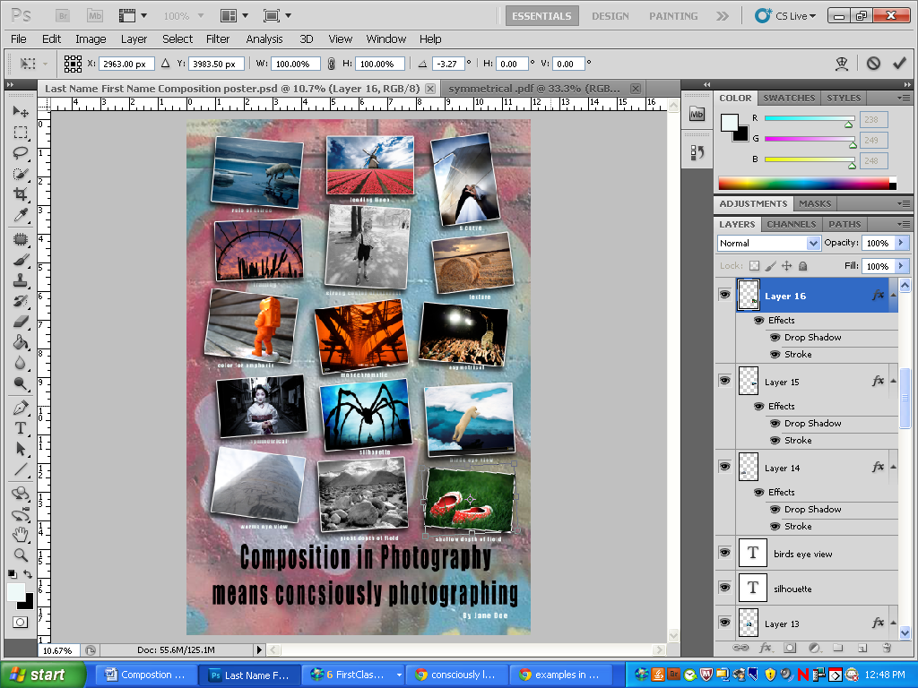

- To create a new Photoshop document, you would start out using functions from this bar:
- If you make a transformation to a photo (change the size or rotation), you can confirm or reject your changes on this bar:
- This tool is called:

- This tool is called:

- The fx button at the bottom of your layers panel allows you to:

Select the BEST composition type for each photograph.
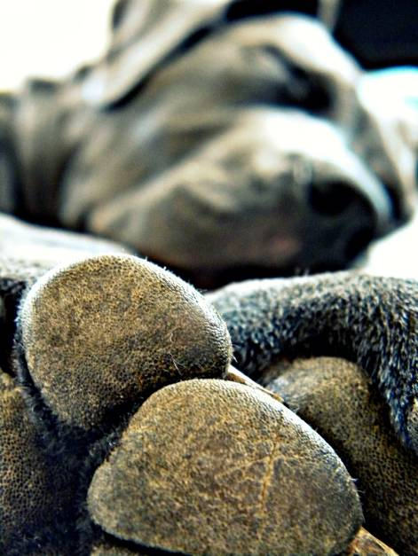
- This photograph is an example of:

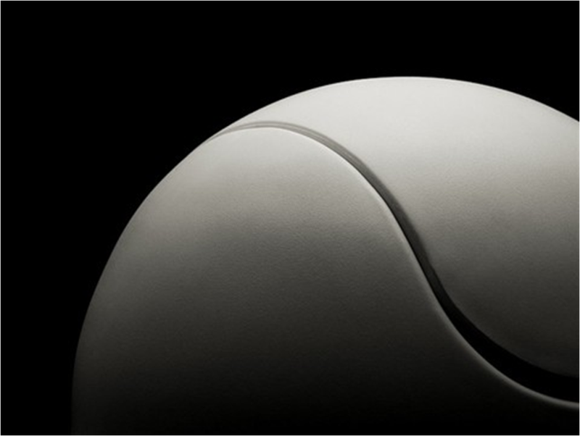
- This photograph is an example of:

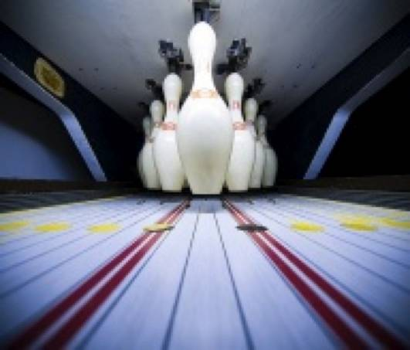
- This photograph is an example of:

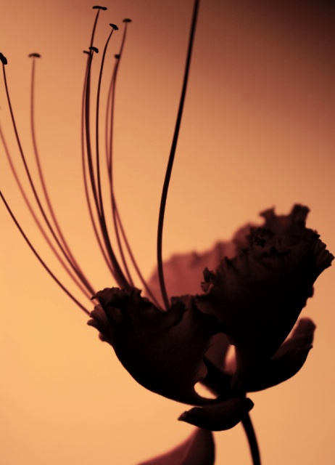
- This photograph is an example of:

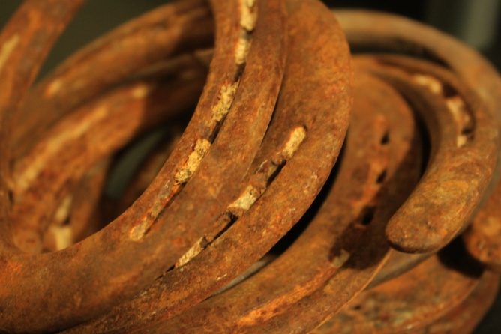
- This photograph is an example of:

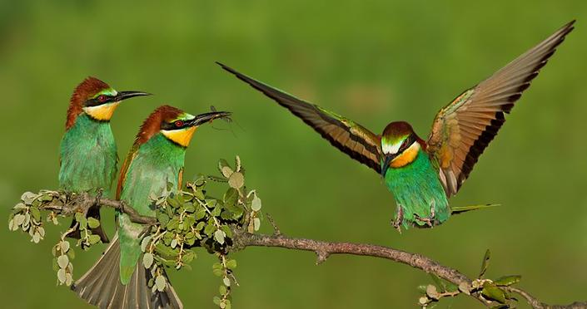
- This photograph is an example of:

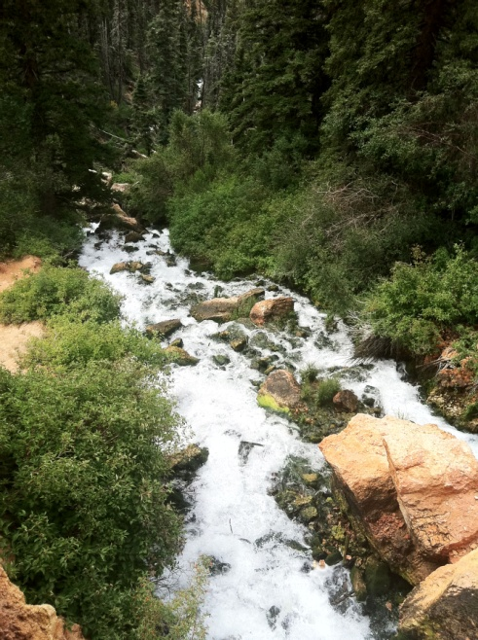
- This photograph is an example of:

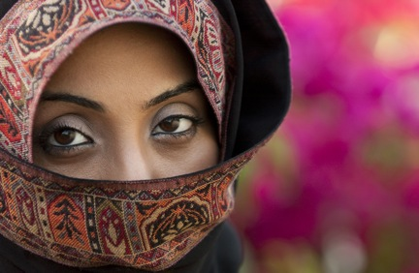
- This photograph is an example of:

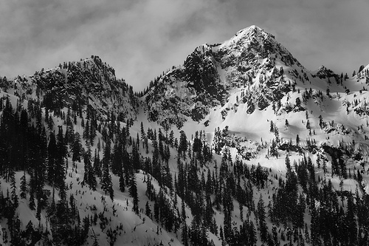
- This photograph is an example of:

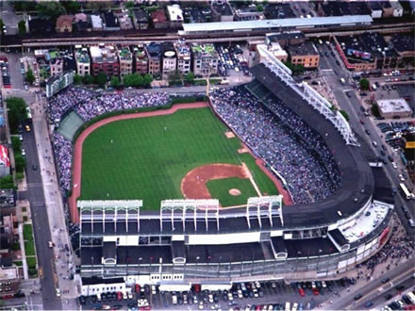
- This photograph is an example of:

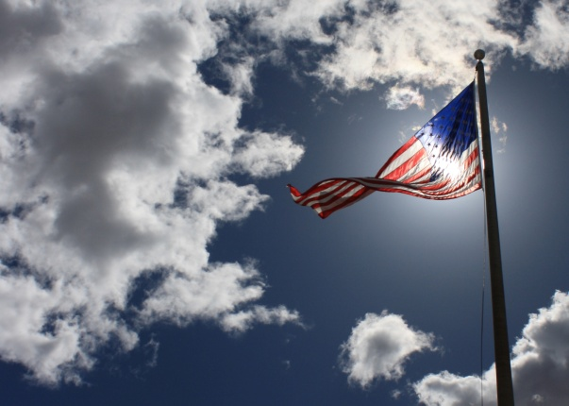
- This photograph is an example of:

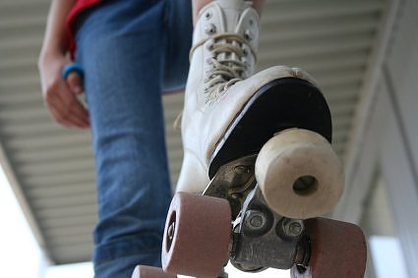
- This photograph is an example of:

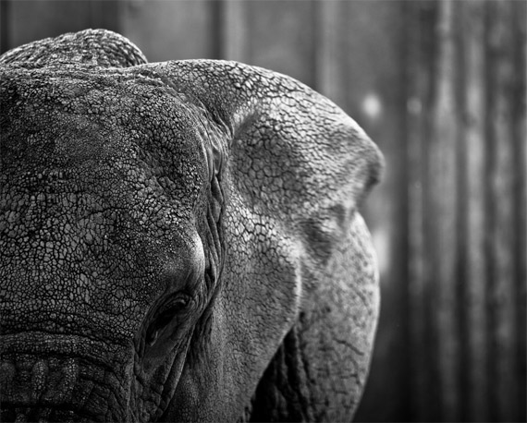
- This photograph is an example of:

Use this diagram to answer questions 94-100:
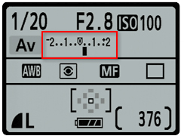

- What is the aperture?

- What is the shutter speed?

- What is the “film” speed?

- What is the camera mode?

- What is the White Balance setting?

- The aperture used will create

- The shutter speed used will create

